Download and decompress：

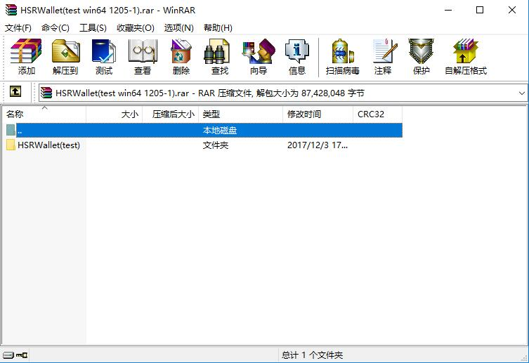

Run the software：

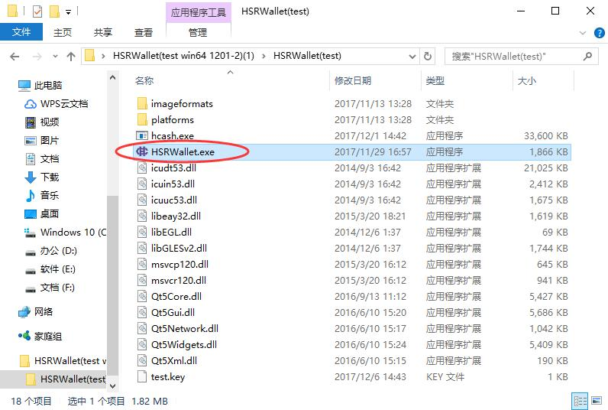

Choose the storage path：

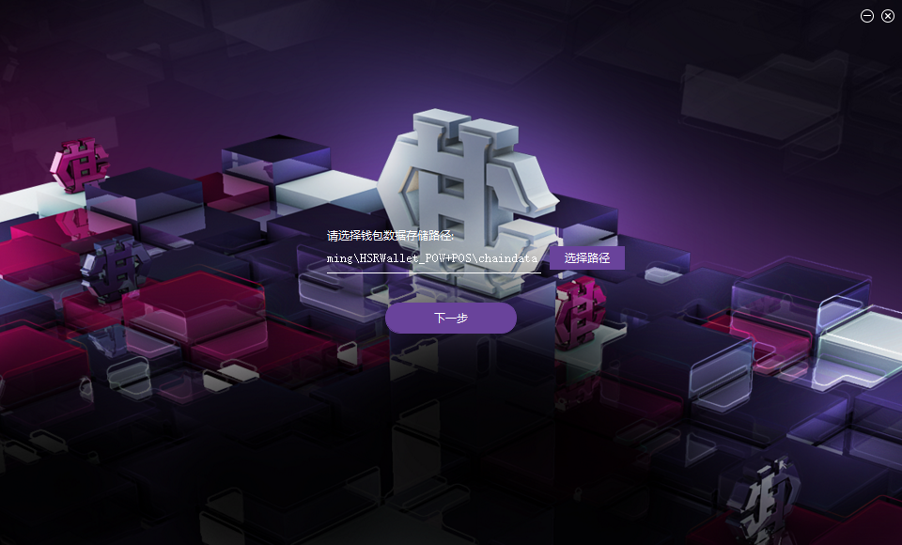

Create a new wallet：

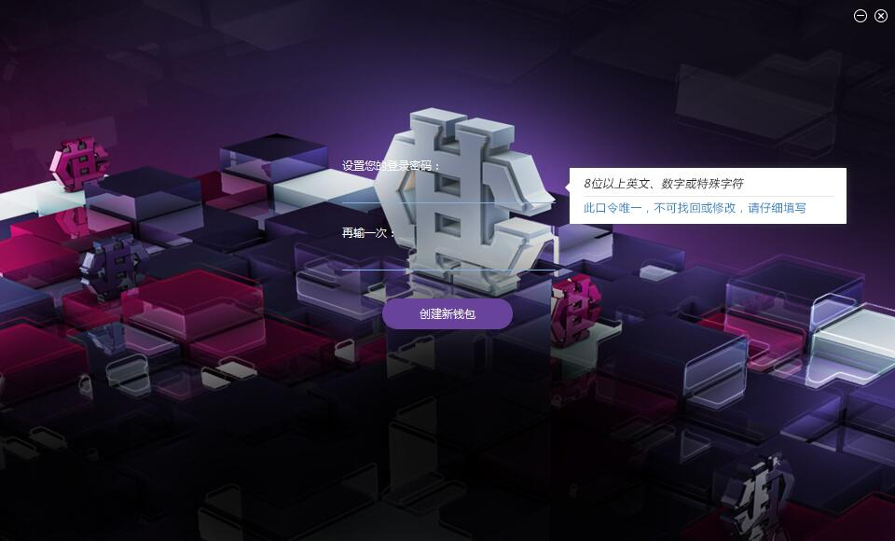

This code will be used to sign in and transfer.

Create a new account：

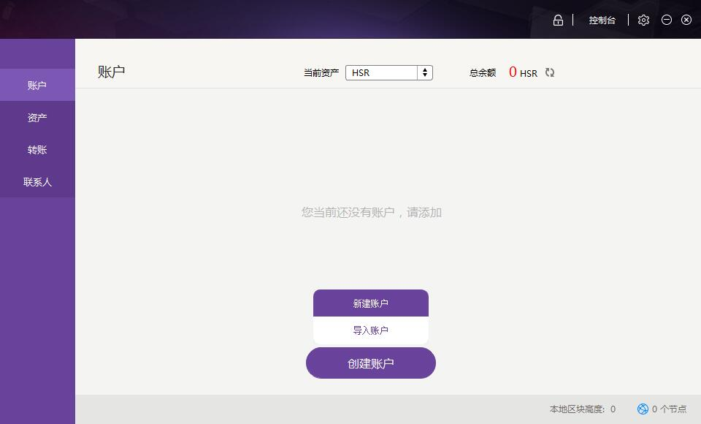

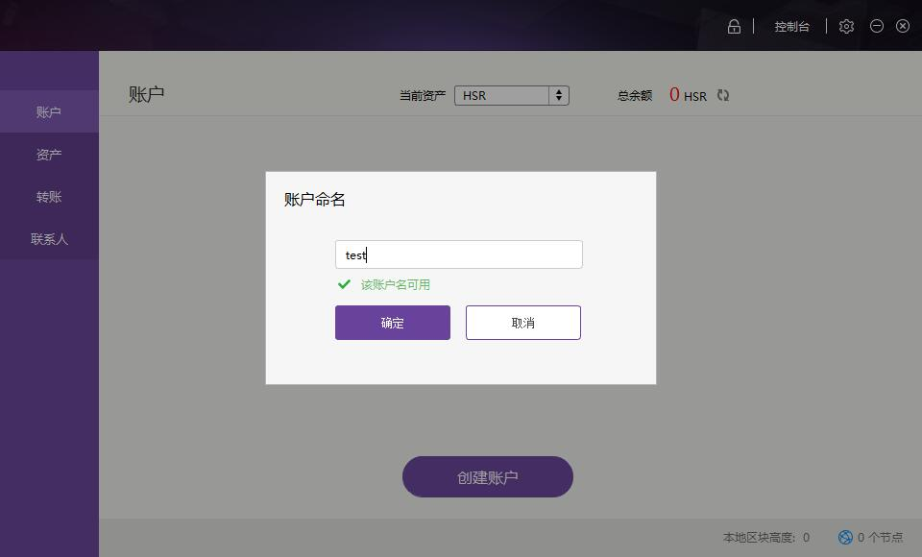

You should backup the private key after creating a new account.

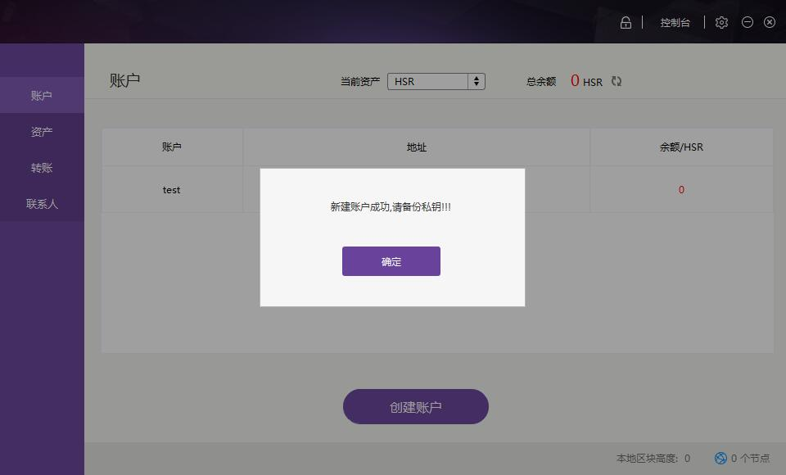

Backup and export the private key.

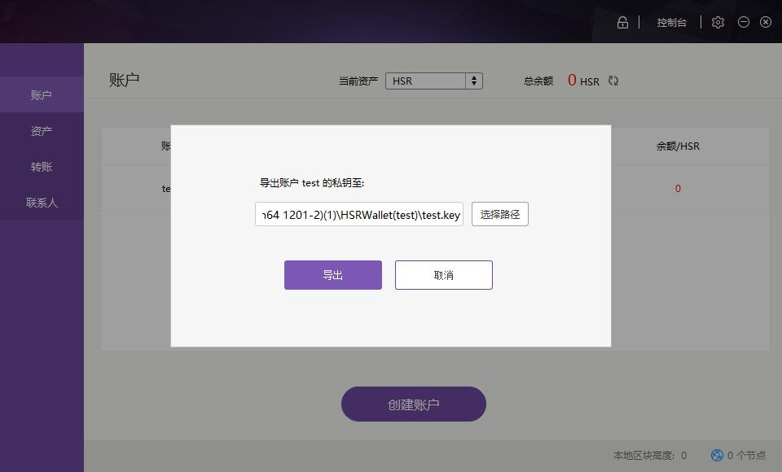

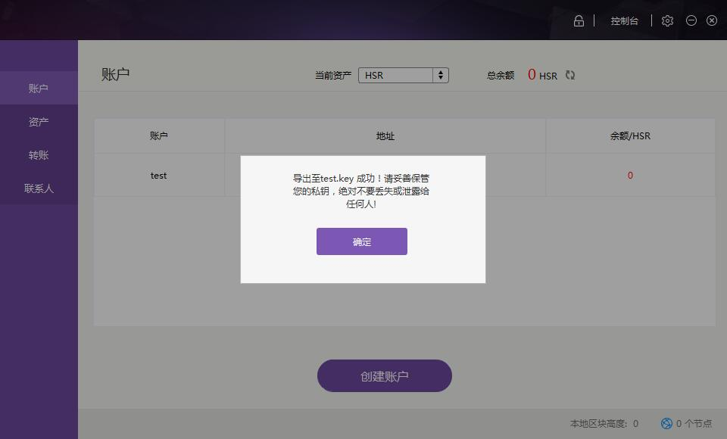

Please backup and keep your private key properly; otherwise your asset will not be able to recovered if the data is lost.

You can also import a private key to create a wallet.

Click import, and find the key document that you backed up before, and import after confirmation.

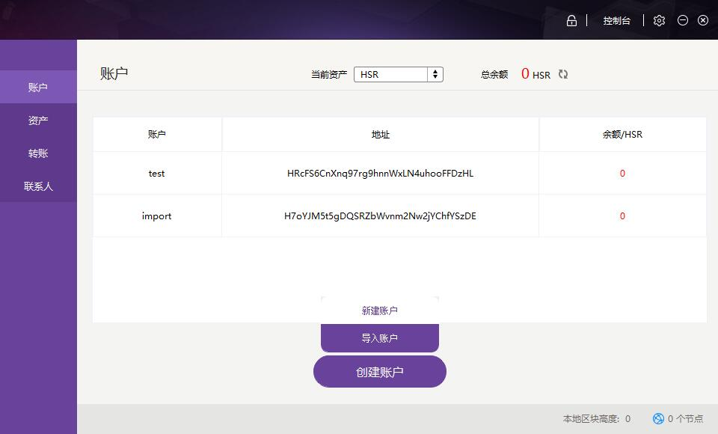

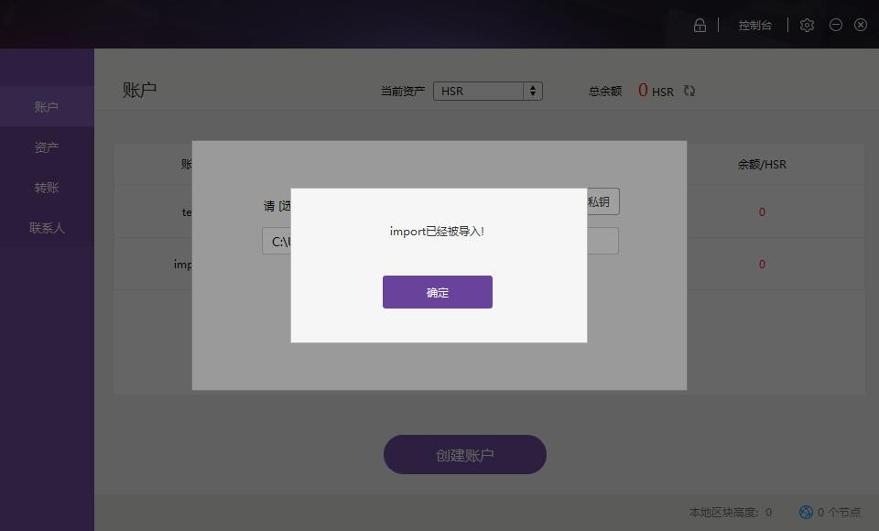

The account is created.

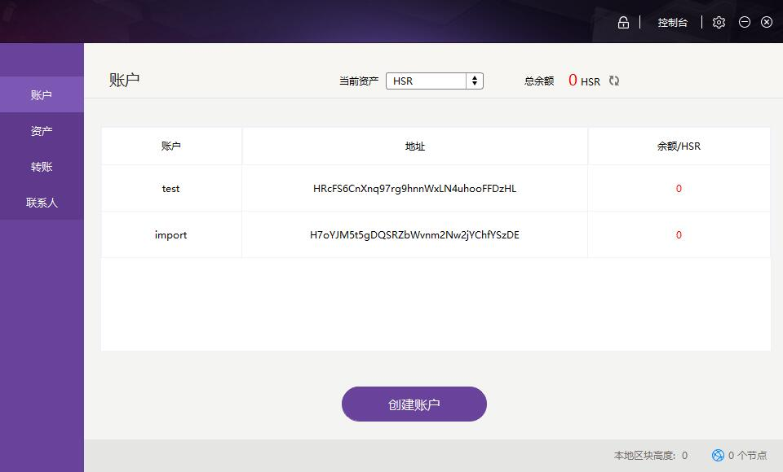

Right click the account address to send your asset to another address.

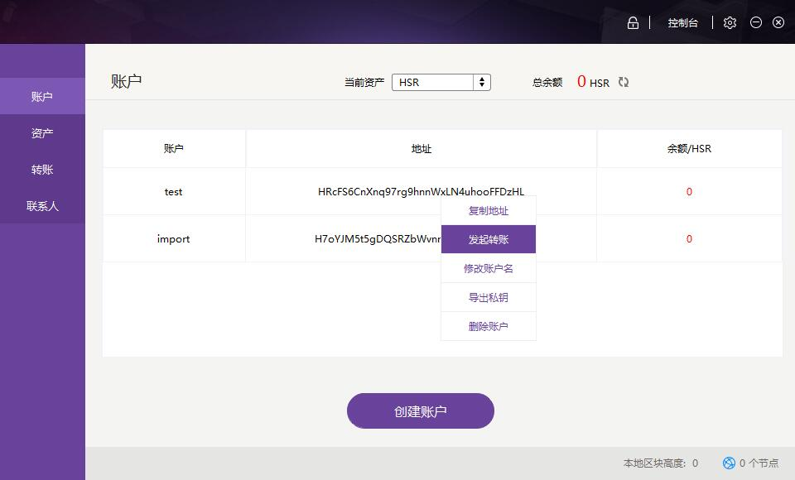

Transfer interface

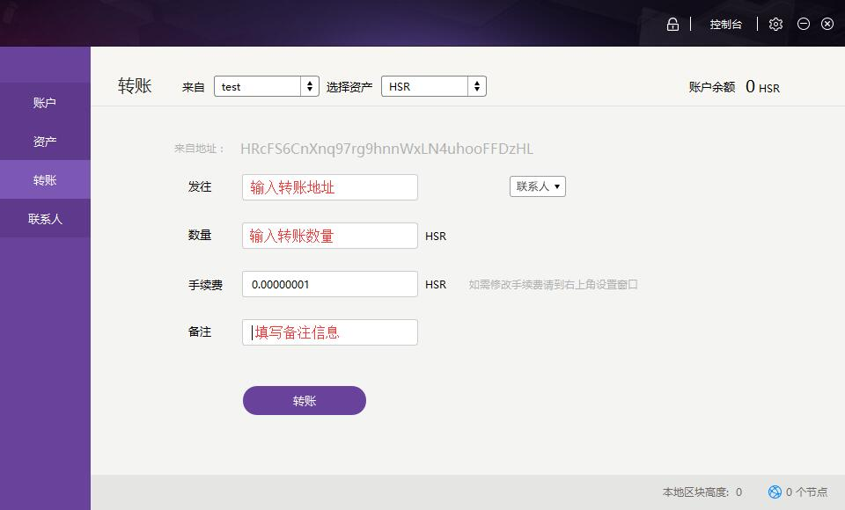

A transfer can be done after completing the information.

Add a contact

Click contact, and click the plus sign at the right corner on the contact interface：

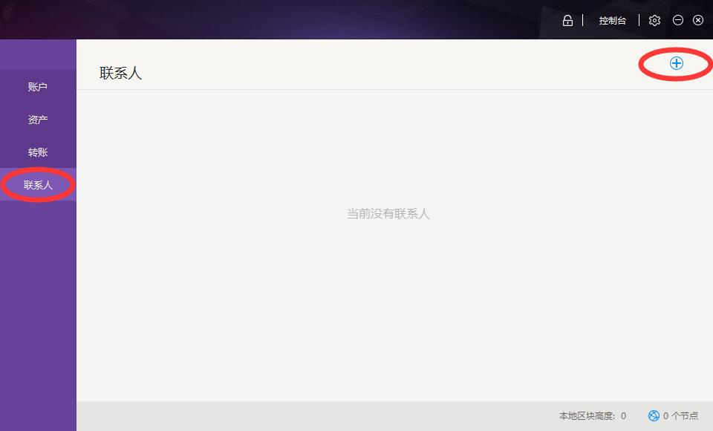

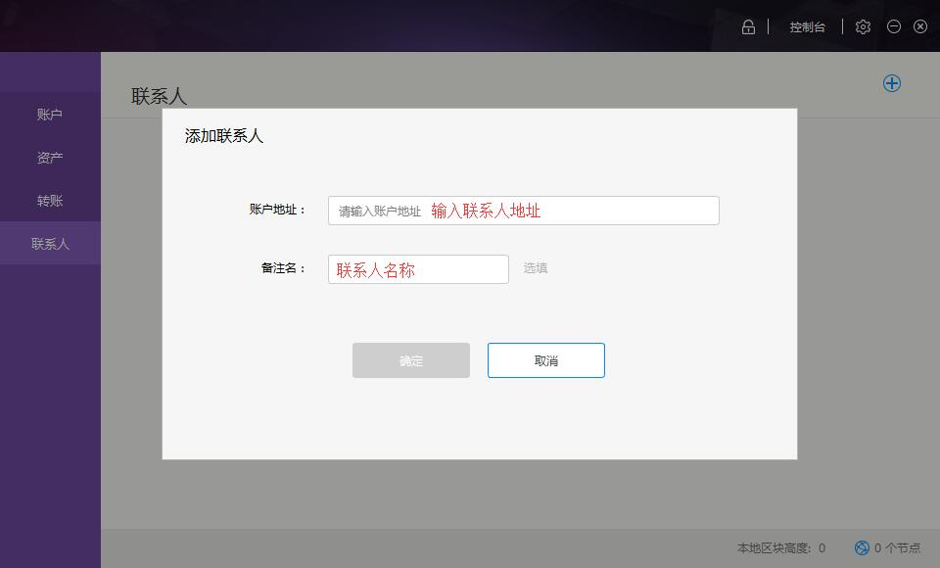

Input information of a contact and click OK to add a contact.